**New features to DataStudio**

**(for adaptation for dbe\_pldebugger and stored procedure override)**

### **The added**

### **1)The added right button menu**

#### Mark line / Unmark line

The tag option is used to mark or unmark lines or whole segments.

Follow these steps to mark / unmark lines in the PL / SQL Viewer or SQL Terminal:

Step 1 Select the target row or the entire segment.

Step 2 Use right-click the row or the entire segment and select Mark Line / Unmark line to do this.

----END

### **2)Code area mark**

**Debug**

On clicking the **Debug** button, you will see an arrow

pointing to the line where breakpoint is set and the line turns highlight. And the arrow indicates the line number at which jumps into a function, Data Studio executes the current statement, and then goes to debug mode, the red dot mark appears at the beginning of the debugging code line, the debugging position is indicated by the arrow in the left ruler area, and the beginning of the executed statement is marked with a green dot.

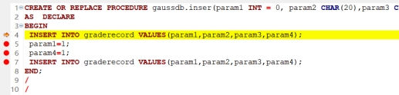

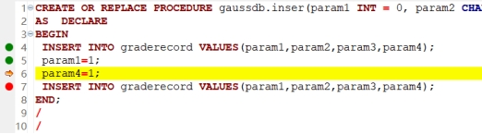

**Debug finished**

After step debugging, the page shows the current code debugging status: the red dot at the beginning of the line indicates the undebugged statement, and the green dot indicates the debugging statement.

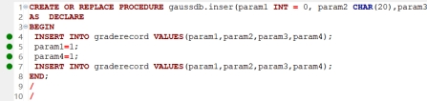

### **3)Toolbar**

**History coverage button**

IMG_261

**View the historical coverage rate**

Click the historical coverage button, and the pop-up window shows the coverage list of this stored process. You can view the process debugging information as needed, or export the document and delete the corresponding function.

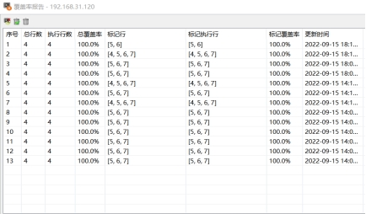

**leading-out**

Click the Export buttonIMG_264 to export the debugging status at that time. The document contains the debugging status and coverage statistical status (if the stored procedure is not highlighted, the code area and mark execution coverage rate display, if selected highlighted, the debugging information of the highlight part will be displayed).

**Delete / Delete in all**

Click delete IMG_265and delete all IMG_266 to delete the coverage information of the stored procedure as required.

### **The changed**

**Execute**

During debugging operation if the connection is lost and the database version is3.0.0and more, the Execute Function/Procedure’sdialog box is added the prompt: If you want to view the coverage, please execute degbug.

